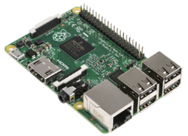
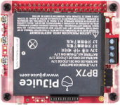
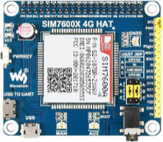
Lab Monitor

About
The Lab Monitor is a custom-built device designed to monitor lab temperature and power outages. It sends SMS alerts to a list of phone numbers in case of high temperature, power changes, and provides daily reports. The device is built using a Raspberry Pi, a SIM7600x GSM modem, a temperature sensor, and PiJuice.

Features
- User friendly web page at device’s IP to check configuration or change any settings.
- Configuration via SMS (Admin-only feature). Type "help" to see available commands.
- Replies to "status" and "time" commands sent via SMS for regular users.
- History logs to keep track of all the events that occurred in the Monitor.

Lab Monitor Installation Dates and Information
- 172.17.175.252
- Installed in ORT lab on 15th October 2024.
- Username: pi
- Password: pi

Replicating device
- Hardware
- You will need:
  - Raspberry Pi
  - WaveShare SIM7600G-H hat
  - Antenna
  - PiJuice
  - Waterproof DS18B20 Temperature sensor
  - A Sim Card with unlimited SMS plan.
- Insert the sim card into the SIM7600x hat
- Place it on top of Raspberry Pi and place the PiJuice on top of the SIM7600x hat.
- Give power to PI to turn the device on or you can power PiJuice and click the ‘SW1’ button to turn the device on.
- Enable serial interface of the PI using `sudo raspi-config`.

- IP Address
- Click on the connection icon on the top right corner of the desktop.
- Navigate to Advanced Options > Edit Connections > Ethernet Wired Connection 1 > IPv4 Settings.
- Edit the IP Address as needed.
- After making the changes, reboot the Raspberry PI and connect it to the Lab Switch.

- Sync Time
- Make sure you have 'timesyncd' installed on your pi by using the 'systemctl status systemd-timesyncd' command. If not install using 'sudo apt-get install systemd-timesyncd'.
- 'sudo nano /etc/systemd/timesyncd.conf' and mention your custom NTP server as 'NTP=172.17.223.167' (Change the IP to any NTP server that is pingable)
- Restart the service 'sudo systemctl restart systemd-timesyncd'.
- Check if it shows connected to time server instead of connecting
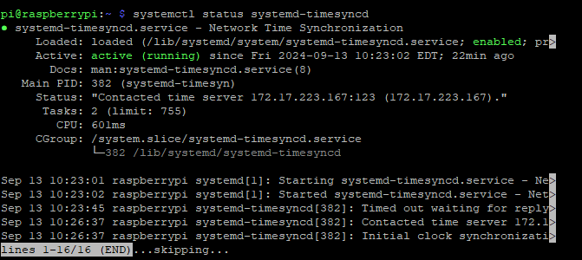

- Connecting the Temperature Sensor
- The sensor has 3 wires, red for voltage, black for ground and yellow for sending data to raspberry pi that uses one wire interface to send data to PI.
- To enable One Wire Interface, at the command prompt, enter sudo nano /boot/config.txt, then add this to the bottom of the file: dtoverlay=w1-gpio,gpiopin=XX (pin of your choice), add all the pins that you have connected the sensors to. Exit Nano
- Similarly, add `w1-gpio` and `w1-therm` to `/etc/modules` file to load kernel drivers that are used to read temperature on boot.
- Reboot the Pi with `sudo reboot`.
- Change directories to the `/sys/bus/w1/devices` folder by entering `cd /sys/bus/w1/devices` and enter ls to list the devices:
- Enter `cd 28-000006637696` (Change numbers to the folder name in your pi)
- Enter `cat w1_slave` which will show the raw temperature reading output by the sensor:
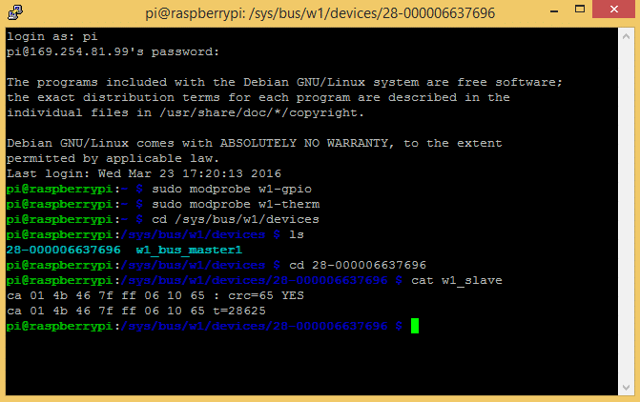
- Software
- Download the source code from GitHub using this link. (or ask Pedro for the source code)
- Install the dependencies in requirnments.txt and install Pi Juice package using `sudo apt install pijuice-base` also install systemd for logging purposes using `sudo apt-get install python3-systemd`.
- `cd` into the project folder and run the project using `python main.py`.
- This should start the Lab Monitor and spin up the web server. The web page should be made available on the device local host’s port 5000. (127.0.0.1:5000)

- Changing ports.
- To access the webpage from the wider network you must set up a Reverse Proxy using nginx.
- To install it, ‘sudo apt-get install nginx’ then enter ‘cd /etc/nginx/sites-available/default’.
- Remove everything and paste:
server {
listen 80;
server_name _;
location / {
proxy_pass http://127.0.0.1:8080;
proxy_set_header Host $host;
proxy_set_header X-Real-IP $remote_addr;
proxy_set_header X-Forwarded-For $proxy_add_x_forwarded_for;
proxy_set_header X-Forwarded-Proto $scheme;
}
}
- Restart the nginx service using ‘sudo systemctl restart nginx’

- Deploying Lab Monitor as a service
- To have the Lab Monitor Server run perpetually, you must deploy it as a service.
- To achieve that, run `sudo nano /etc/systemd/system/monitor.service` and paste the following into that file.
[Unit]
Description=Server Service
After=multi-user.target

[Service]
Type=simple
WorkingDirectory=/home/pi/GSM-Alarm
ExecStart=/usr/bin/python3 /home/pi/GSM-Alarm/main.py
Restart=always
RestartSec=3

StandardOutput=journal
StandardError=journal
SyslogIdentifier=LabMonitor
User=pi

[Install]
WantedBy=multi-user.target

- Run the commands `sudo systemctl daemon-reload`, `sudo systemctl enable monitor.service` and `sudo systemctl start monitor.service` one by one to start the service.

Debugging
- To check live logs write `journalctl -u monitor.service -f `to see live logs of the Lab Monitor.
- If any unexpected bug disrupts the service, `sudo systemctl restart monitor.service`

How to Use
- Power on the device
- Plug the device into power to turn it on.
- Connect the PI to a network switch and power it on.
- Access the Web Page
- Wait about 10 seconds for the web server to spin up.
- Open a web browser and navigate to the device's IP address.
- You can see the device configuration and can navigate to the help page, settings page and the history page from on the website.

